Our History
The Rio Linda/Elverta Historical Society was formed in February 1991 by a group of individuals concerned about preserving the unique history of these two communities. All historical material is being collected including old photographs, historical items and artifacts, newspapers, historical records, individual and family histories and stories, and historical data and photos on past and present businesses, schools, organizations and churches.
Our Goals
The Rio Linda / Elverta Historical Society is dedicated to achieving the following:
- Preservation of the historical heritage of the Rio Linda and Elverta communities;
- Promotion of greater public awareness of the history of this area;
- Restoration of the Dry Creek Ranch House;
- Establishment of a museum of Rio Linda and Elverta historical artifacts in the Dry Creek Ranch House;
- Restoration and maintenance of Rio Linda Fire Dept. Fire Engine No. 7;
- Working together with local organizations for the betterment of our communities.
Memorial Rose Garden
The society has established and maintains the Pioneer Memorial Rose Garden with a large variety of roses providing a beautiful background for events and weddings. Memorials have been set up within the rose garden by those who desire to create a living legacy to friends and loved ones.
Dry Creek Ranch Rental
The Dry Creek Ranch grounds are available for special events and weddings. Contact Joyce Buckland at (916) 335-4359 for fees and dates available.
Sunday Socials
Socials are held at 2:00 p.m. on the third Sunday of the month except as follows:
- May – Farm & Tractor Days (no social)
- June – second Sunday
- November – no social
- December – first Sunday (1:00 p.m.)
Winter months the socials are held in the social hall of Calvary Lutheran Church, 5th & L Streets, Rio Linda. All other socials are held at the Dry Creek Ranch, 6852 Dry Creek Road, Rio Linda, California.
Farm & Tractor Days
This annual fund raiser is held for two days in May each year and features demonstrations and displays of antique tractors and engines.
Classic Car Show
The society is a co-sponsor for this second fund raiser of the year and it is held in the late summer featuring many incredibly restored cars.
Membership Fees
Membership year is January through December. Fees are as follows:
- Individual - $20
- Family - $25
- Organizations - $30
Website:
Rlehistorical.org
Contacts:
Jason Green, President – (916) 991-1482
Joyce Buckland, Treasurer – (916) 335-4359
Rio Linda/Elverta Historical Society
PO Box 478, Rio Linda, CA 95673-0478
Membership Form
Please enroll me (us) for membership:
Name:______________________________________________________________________________________ Address:____________________________________________________________________________________ City/State/Zip Code: _________________________________________________________________________ Telephone:____________________________ E-Mail:______________________________________________
Enclosed is $ ______for _____membership(s).  $20 Individual  $25 Family*  $30 Organization*

Your birthday: _______________ Spouse birthday: ________________ Anniversary: _________________
*Entitles family to one copy of publications.
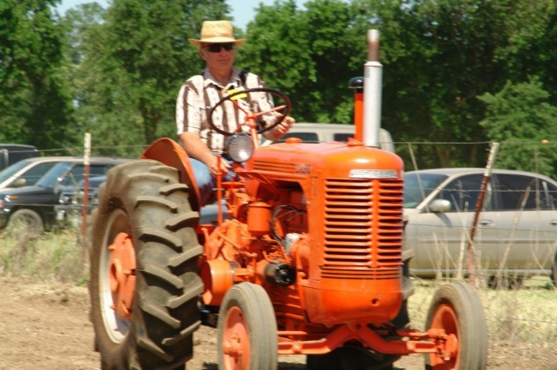
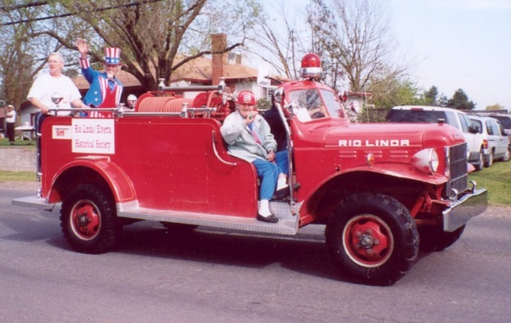
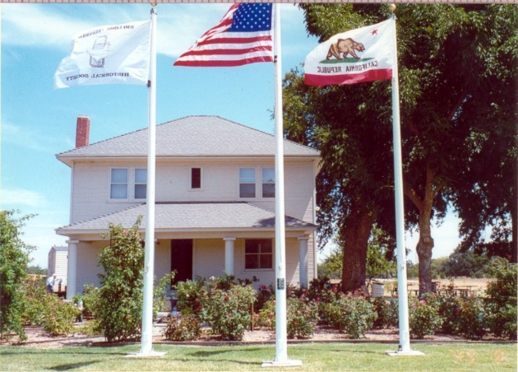
Farm & Tractor Days participant
Rio Linda Fire Dept. Engine No. 7
The Dry Creek Ranch House & Museum
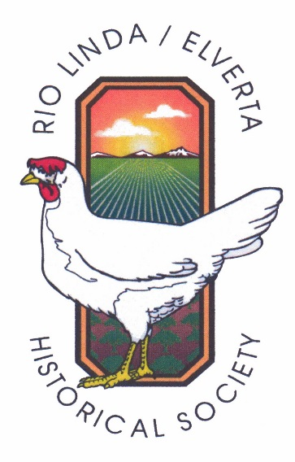

Welcome
to the
Rio Linda/Elverta
Historical Society

Dedicated to preserving the unique history of
Rio Linda and Elverta

Founded 1991

Sunday Socials
With
Special Guest Speakers

Dry Creek Ranch
House Museum

Pioneer Memorial
Rose Garden

Farm & Tractor Days

Classic Car Show

Summer Potlucks &
Ice Cream Social

Christmas Potluck
& Gift Raffle

The Mini-Eggspress
Published Quarterly

Restoration of
Rio Linda Fire Truck
No. 7

Farm & Tractor Days participant

